PUNE INSTITUTE OF COMPUTER TECHNOLOGY

DHANKAWADI, PUNE – 43

CLASS: F.E.(COMMON) SUBJECT: BXE
EXPT. NO.: 10 DATE:

TITLE: Case Study of any one electronic appliance.

OBJECTIVE: -To know about the specifications of modem + Router Dual system
-To know about other manufactures of the same product
-To understand the block diagram and the working principle of the device

THEORY: TP-LINK TD-W8961N 300Mbps fixed Antenna Wireless N ADSL2+ Modem Router

1)INTRODUCTION:
Modem basically does modulation and Demodulation.
Modem receives the analog signal from the internet cloud. This signal is received via cables from our telephone wires. The DSL port is used to connect the modem to the cloud (Outside World i.e. the internet). This analog signal cannot be read by our computer so the modem modulates the signal into a digital one so that our computers can read that signal. The Ethernet connector is used to connect the modem to our computer or to the router.
Router provides a route from one device to multiple devices. Router can be wired or wireless. It provides route via channels. We can connect Chromecast, TV, phones, laptops, computers, Radios, Smart Watches, Smart homes lie google home, Alexa and many more devices with the help of router. Router provide a bridge between the cloud (Internet) and our home Devices.
Nowadays we can get devices that can work as a modem as well as a router at the same time. The antenna mounted on the devices help it to work as a router to connect devices wirelessly.
2) SPECIFICATIONS:
HARDWARE FEATURES
Interface | 4 × 10/100Mbps LAN Ports  1 × 10/100Mbps WAN Port
Button | WPS/Reset Button  Wireless On/Off Switch  Power On/Off Button
External Power Supply | 12VDC/1A
Dimensions ( W x D x H ) | 9.1×5.7×1.5in. (230×144×37mm)
Antenna | 3 × 2.4GHz Antennas  2 × 5GHz Antennas

WIRELESS FEATURES
Wireless Standards | IEEE 802.11ac/n/a 5GHz  IEEE 802.11b/g/n 2.4GHz
Wireless Speeds | 450Mbps(2.4GHz)  867Mbps(5GHz)
Frequency | 2.4-2.5GHz  5.15-5.25GHz
Transmit Power | CE:  <=20dBm （2.4G）  <=23dBm （5G）
Wireless Modes | Wireless Router  WDS(Four Address)  WDS(AP+APC)
Wireless Security | WEP  WPA\WPA2  WPA-PSK\WPA2-PSK

SOFTWARE FEATURES
Quality of Service | WMM, Bandwidth Control
WAN Type | Dynamic IP/Static IP/PPPoE/  BigPond/ /L2TP(Dual Access) /PPTP(Dual Access)
Management | Access Control  Local Management  Remote Management
DHCP | Server, Client, DHCP Client List, Address Reservation
VPN Pass-Through | PPTP  L2TP  IPSec
Access Control | Parental Control  Local Management Control  Host List  Access Schedule  Rule Management
Protocols | IPv4  IPv6
Guest Network | 2.4GHz guest network  5GHz guest network

OTHERS
Certification | CE, RoHS
Package Contents | AC1350 Wireless Dual Band Router Archer C60  Power supply unit  Ethernet Cable  Quick Installation Guide
Environment | Operating Temperature: 0℃~40 ℃ (32 ℉~104℉)  Storage Temperature: -40℃~70 ℃ (-40 ℉~158℉)  Operating Humidity: 10%~90% non-condensing  Storage Humidity: 5%~90% non-condensing
Operating System | Microsoft Windows XP/Vista/7/8/8.1/10  MAC OS, NetWare, UNIX or Linux

3) OTHE MANUFACTURERS:
- D-Link
- Netgear
- Motorola
- Cisco-Linksys, LLC
- Belkin
- Huawei
- Beetle

4) BLOCK DIAGRAM:
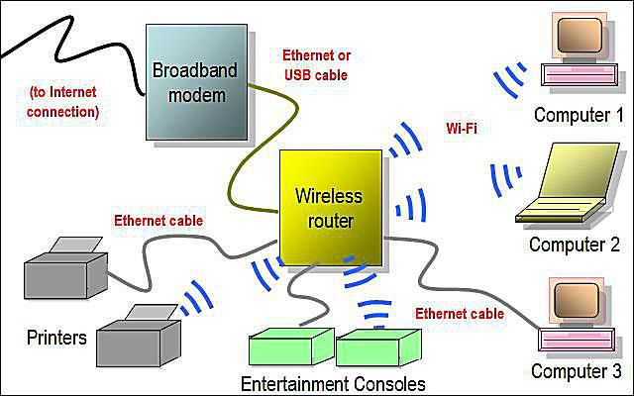

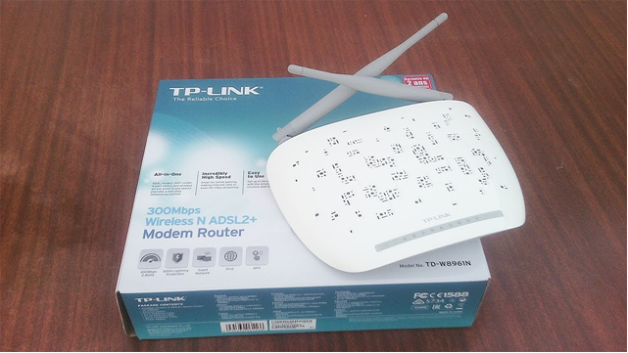
5) WORKING PRINCIPLE:
It works on the data-link layer of the ISO-OSI reference model and provisions the transmission of data packets. The modem performs the modulation and demodulation function in between your networking devices such as a computer or router and the telephone line.
The main purpose of using a modem is that it connects the networking system or device to the Internet service provider (ISP) and we can get access to the Internet only by using a modem.
The connection between the modem and the networking device is done by using RJ45 cable and between the modem and telephone line is by using RJ11 cable.
To put it simply, a router connects devices within a network by forwarding data packets between them. This data can be sent between devices, or from devices to the internet. The router does this by assigning a local IP address to each of the devices on the network. This ensures that the data packets end up in the right place, rather than getting lost within the network.
6) COST OF ELECTRONICS APPLICANCE:
Rs 1,349 on Amazon, India

7)CONCLUSION :
-Specifications of modem + Router Dual system are known.
-Other manufactures of the same product are known.
-The block diagram and the working principle of the device is understood.

Teacher Sign with Date Remark

REFFRENCE:Wikipedia
- Wikipedia
- https://www.tp-link.com/in/home-networking/wifi-router/archer-c60/
- www.google.co..in
- https://www.makeuseof.com/tag/technology-explained-how-does-a-router-work/

